|  |  |  |
| --- | --- | --- |
| Национален институт по  метеорология и  хидрология | Original_logo_with_1890_black_white_grey_final_last | National Institute  of Meteorology  and Hydrology |
| Bul. J. Meteo & Hydro 28/1 (2024) | | |

Title of the paper – indicative but not too long

Author’s First name and Family name1[[1]](#footnote-1)\*, Author’s First name and Family name2

1Affiliation (e.g. National Institute of Meteorology and Hydrology,

Tsarigradsko shose 66, 1784 Sofia, Bulgaria)

2Affiliation (e.g. National Institute of Geophysics, Geography, Geodesy, Bulgarian Academy of Sciences (NIGGG - BAS),

Acad. G. Bonchev, Block 3, 1424 Sofia, Bulgaria)

**Abstract:** Abstract should not exceed 500 words. It should be written with 10 pt Times New Roman font, justified, paragraph spacing 18 pt before and 6 pt after, with 1 cm left and right indent.

**Keywords:** Keywords should be maximum 5, written with 10 pt Times New Roman font, justified, paragraph spacing 18pt before and 6pt after, with 1 cm left and right indent.

1. TITLES OF THE SECTIONS

Page size has to be 16.5 x 23.5 cm. All materials should fit within the following margins: 2.00 cm from the top and the bottom, 1.5 cm from the right and left.

Papers are accepted in English, American spelling. For the issue(s) published in Bulgarian language, all papers should have titles, abstracts, figure captions and table titles in both Bulgarian and English.

Title of the paper should be in 14 pt Times New Roman font, bold, centered on the page, in sentence case style, with spacing 18 pt before and 18 pt after. Title should be informative and not too long.

Full names of all the authors should be in 11 pt Times New Roman font, bold and centered on the page, with spacing 0 pt before and 12 pt after. The e-mail address of the corresponding author should be given in the footnote.

Affiliations and postal addresses should be in 11pt Times New Roman font, italic, centered on the page, with no spacing before and after (0 pt).

Times New Roman 11 pt font should be used for the whole body text, including the titles of the sections and sub-sections. The text should be justified and single line space must be applied. Sections should be numbered correspondingly, their titles written in Times New Roman 11 pt font, bold, UPPERCASE style, with spacing 18 pt before and 6 pt after.

First line of the paragraph after the section’s title is justified (with 0 pt special indent), while the first lines of the subsequent paragraphs should have a special indent by 0.5 cm.

Authors should follow SI units. Units are not italicized. Ex.: The total precipitation amount for 21 May 2016 was 20 mm at station X.

**1.1. Sub-section’s title**

The titles of sub-sections should be numbered correspondingly, written in Times New Roman 11 pt font, bold, sentence case format. The formatting of the section’s titles should be with spacing 18 pt before and 6 pt after.

***1.1.1. Sub-sub section’s title***

The titles of sub-sub sections should be numbered correspondingly, written in Times New Roman 11 pt font, bold, italic, sentence case format. The formatting of the section’s titles should be with spacing 18 pt before and 6 pt after.

**2. EXAMPLES FOR FIGURES, TABLES AND FORMULAE**

All figures (Figure X) and tables (Table X) should be placed in the text body as close to the reference as possible. Figures should be numbered and their captions with Times New Roman 10 pt placed below them and centered on the page. Color or black figures should be designed in an appropriate format according to the page size and margins, so that to be well visible when printed. Raster images should be not less 300 dpi in the natural size.

Tables should be numbered separately from the figures, with captions in 10 pt Times New Roman, placed above them and left aligned. Tables should not be too bulky.

Examples for figures and tables formatting follow.

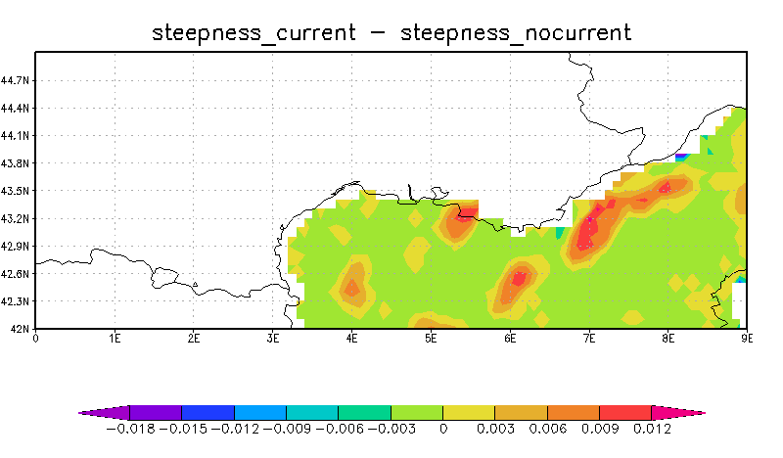

Fig. X. Wave steepness difference between simulations with and without wave-current interactions.

**Table 1.** WCF (W/m*2*) scale of thermal sensations for winter outdoor conditions

|  |  |
| --- | --- |
| from 1628 to 2326 | - frosty |
| from 930 to 1628 | - cold |
| from 582 to 930 | - cool |
| from 233 to 582 | - comfortable |
| from 116 to 233 | - warm |
| from 58 to 116 | - hot |
| > 58 | - extremely hot |

Formulae should be with 2 cm left indent, numbered consecutively on the right hand side. An example follows:

 (1)

3. CONCLUDING REMARKS/ CONCLUSIONS

Citations within the text should be placed in parentheses with the author’s last name and year separated by a comma. The “et al.” construction should be used for citations with three or more authors. Example: (Panchev, 1985), (Petrov&Ivanov, 2016), (Booij et al., 1999). If the authors’ names are included in the sentence, only the year should be placed in parentheses. Example: …as stated in Petrov (2016). Multiple references should be listed alphabetically and separated by semicolons. Example: (Agov, 2000; Botev, 2016; Cacic et al., 1999).

References should be in 10pt TNR, left hanging by 0.5 cm. They should be completed in the following style: (a) for journal articles - author(s), year in parentheses, paper title, journal name, volume, inclusive page numbers; (b) for books - author(s), year in parentheses, title, publisher, number of pages: (c) for contribution in a book: author(s), year in parentheses, title of the contribution, In: editor(s), title, publisher, page numbers. When citing an internet site, only short title of the document should be written in the text, the link given in the references Ex.: (BarentsWatch Directive (2007)/2/EC).

When in a paper, written in English language, one wants to cite materials originally written in other language, it is accepted to mention the cited material in English and to put in parentheses in which language it is – (see example in the References).

Reference list: The list of literature should be, preferably, in alphabetic order.

ACKNOWLEDGEMENTS (if any)

This work has been done as a collaboration between NIMH and…. The authors wish to express their gratitude to …. for the fruitful discussions ….. or This work was supported by National Science Fund under Grant No. 12345….. or The support of the Alexander von Humboldt Foundation is also acknowledged.

REFERENCES

BarentsWatch (an open information system), <https://www.barentswatch.no/en/>

Booij, N., Ris, R., Holthuijsen, L. (1999) A third-generation wave model for coastal regions 1 Model description and validation, Journal of geophysical research 104(C4), 7649-7666

Directive (2007)/2/EC of the European Parliament and of the Council of 14 March 2007 establishing an Infrastructure for Spatial Information in the European Community (INSPIRE), <https://www.esmis.government.bg/page.php?c=107>

Abdul-Kadar, F., Xu, H. and Gao, P. (2016) On-the-fly analysis of multi-dimensional rasters in a GIS, Proceedings, 9th Symposium, Intern. Soc. for Digital Earth, IOP Conference Series: Earth and Environmental Science, 34(1) 012001, doi:10.1088/1755-1315/34/1/01200

Pereira, S., Wagner, F., Silva, A. M. (2008) PM10 air quality assessment in several Portuguese rural cities, Proceedings of European Aerosol conf., 9-14 September 2007, Salzburg, Austria

Andreev, V. (2014) History of the Bulgarian meteorological and hydrological service, “Prof. Marin Drinov” Publisher, 250 pp. (in Bulgarian)

Kercheva, M. (2004) Information basis for modelling components of soil water balance and assessment of agroecological risks. PhD Thesis. “N.Poushkarov” Institute of soil science, Sofia, 143 pp. (in Bulgarian)

Manual on Codes WMO (2015) WMO No 306, Volumes I.1 and I.2, World Meteorological Organisation, ISBN 978-92-63-10306-2

Panchev, S. (1985) Dynamic meteorology, Reidel Publ. Co, Dordrecht/Boston/Lancaster; Environmental Fluid Mechanics 4, 360 pp.

Pedlosky, J. (1982) Geophysical fluid dynamics, Springer Verlag (Russian translation 1984)

Pereira, S. N. (2006) Utilisation of new methods for measurements of aerosol properties, (in Bulgarian), Master thesis, Sofia University, 110 pp.

Hinds, W. C. (1999) Aerosol Technology: Properties, Behaviour and Measurements of Airborne Particles, 2nd Edition, John Wiley&Sons, New York, 483 pp.

1. \* corresponding author’s Email address [↑](#footnote-ref-1)